Epoxy/glass fibres laminates with integrated layer of carbon tubes decorated by Ag clusters for deformation detection

S. Lloret Pertegás^{1*}
P. Slobodian² , J. Matyas² , Robert Olejnik², R. Schledjewski¹

¹Christian Doppler Laboratory for High Efficient Composite processing, Department Polymer Engineering and Science, Montanuniversitaet Leoben, Otto Gloeckel-Strasse 2, A-8700 Leoben, Austria.
²Centre of Polymer Systems, University Institute, Tomas Bata University, Trida T. Bati 5678, 760 01 Zlin, Czech Republic

*silvia.lloret-pertegas@unileoben.ac.at

Keywords: Composite Processing, Strain Sensors, Epoxy laminate, Vacuum infusion, CNTs, carbon nanotubes

Abstract

With the aim to develop a multifunctional material, two concepts were joined, composite manufacturing and sensing. Using vacuum infusion technology, carbon nanotubes (CNTs) filtered in a polyurethane membrane were integrated in a glass fiber reinforced epoxy laminates. In this study a modified CNTs decorated by Ag inclusions were used as strain sensors for deformation detection, based on the principle of crack sensors, were ultrahigh sensitivity is attributed to disconnection-reconnection process between the nanotubes and increased by the metal-metal (Ag-Ag) link. CNTs with Ag inclusions sensors showed extraordinary results in measuring changes in the electrical conductivity compared with pure CNTs, after applying pre-strain forces which increases strongly the sensitivity to changes in electrical resistance. CNT-based sensing elements are capable to deliver process monitoring performance combined with additional functionality such as passive antenna functionality or gas detection, to be utilized over life time. Furthermore CNT-based patches can be used as heating elements.

- Introduction
Strain sensing composite materials have attracted considerable attention for their unique characteristics exceeding conventionally applied materials. Between different solutions and various types of transducers available for these applications, piezo-resistive strain sensors are among the most investigated ones [1-6]. They are usually based on conductive polymer composites (CPCs) prepared by embedding of electrically conductive fillers as carbon nanotubes into a polymeric matrix. Here the carbon nanotube films are usually deposited on thicker flexible polymeric substrate which acts as a mechanical support and transfer mechanical stimulus to carbon strain sensitive layer [1-6].
The piezoresistive behavior of these nanocomposites is attributed to nanotube-nanotube contact and separation of tunneling gaps resulting from deformation and reconfiguration of the conductive networks while strain. Carbon nanotubes decorated by conductive particles improve the strain transfer, durability and reproducibility of the sensor [7,8], due to the crack formation and propagation given by the Ag clusters showing a remarkable increase in electrical resistance change. As the Ag is conductive, its resistance depends on strain. When strain is applied to the length section of the sensor, it increases and cross section area decreases. These two effects can explain the resistance rise of the strained section of conductor. CNT-based multifunctional and smart material is developed by vacuum infusion with electrical, thermal and sensing properties.
- Experimental

Materials
Strain sensitive layer based on MWCNTs/Polyurethane semi-product further incorporated into epoxy/glass fibres sheets was prepared as thermoplastic polyurethane (TPU) based composite with layered network of entangled multi-walled carbon nanotubes. Polyurethane, Desmopan 385S was used supplied by Bayer MaterialScience. Desmopan 385S is a polyester based thermoplastic polyurethane elastomer. PU properties provided by the manufacturer reveal mass density 1200 kg/m³, injection molding temperature 210 - 230 °C, shore hardness 85 (method A), ultimate tensile strength 40 MPa and strain at break 450 %.

Polyurethane/MWCNT semi-product composite
Aqueous dispersion of MWCNTs was prepared by sonication in an apparatus UZ Sonopuls HD 2070 for 15 minutes at room temperature. The nanotube concentration in the suspension was 0.3 wt.%. Dispersion contained also surfactants, namely sodium dodecyl sulfate and 1-pentanol with concentration 0.1M and 0.14M, respectively. Moreover, NaOH aqueous solution was added to adjust pH to 10. For making an entangled MWCNTs network, a porous polyurethane membrane and a vacuum filtration method was used. 30 ml of homogenized dispersion was filtered through the funnel of diameter 90 mm. The prepared MWCNTs network was washed several times with deionized water (65 °C), afterwards by methanol in situ and dried between two filtration papers for 24 hours.

Epoxy/glass fibre composite with sensory MWCNT/PU layer
Composite sheets were manufactured with EPIKOTETM resin, and EPIKURETM RIMH 1366 as curing agent. Each laminate was cured during 24 hours at room temperature. Carbon nanotubes films were placed in between the layers of bidirectional glass fiber, according with the requirements of the tests. The schematic illustration of fabrication process is presented in figure 1. The change of sensor electric resistance was measured lengthwise by the two-point technique using Multiplex datalogger 34980A with storage of data once per second.

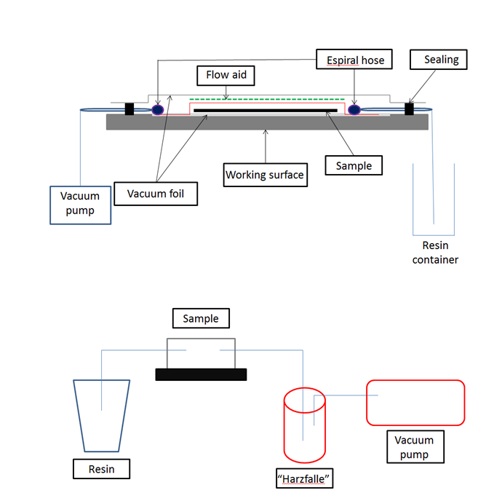

Fig. 1 The schematic illustration of fabrication process of epoxy/glass fibre composite with integrated MWCNT/PU strain sensitive layer.
- Results and discussion

The scanning electron microscope (SEM) analysis, by NOVA NanoSEM 450 (FEI), of PU non-woven filtering membrane is presented in Fig. 2 a). Individual nanotubes are entrapped by filtering membrane in the course of MWCNTs aqueous dispersion vacuum filtration. The nanotubes infiltrate into membrane pores which are finally blocked by a filtering cake made of pure network of entangled MWCNT is created. SEM micrograph in Fig. 2 b) shows the upper surface of MWCNT network. MWCNT network is a porous and electrically conductive structure created by entangled nanotubes with electrical conductive junctions between individual tubes.
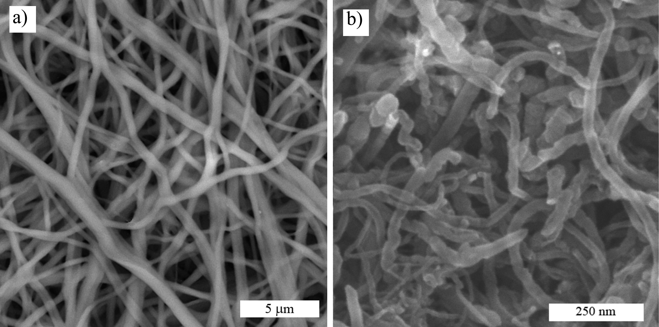
Fig. 2 a) SEM micrograph of polyurethane non-woven filtering membrane, b) SEM image of the upper surface of entangled MWCNTs network.

Chemical deposition of Ag clusters was performed by reduction from AgNO₃ solution by sodium salt of citric acid. SEM analyses of Ag clusters deposited on MWCNT surface is presented in Fig. 3 and test specimen in Fig. 4

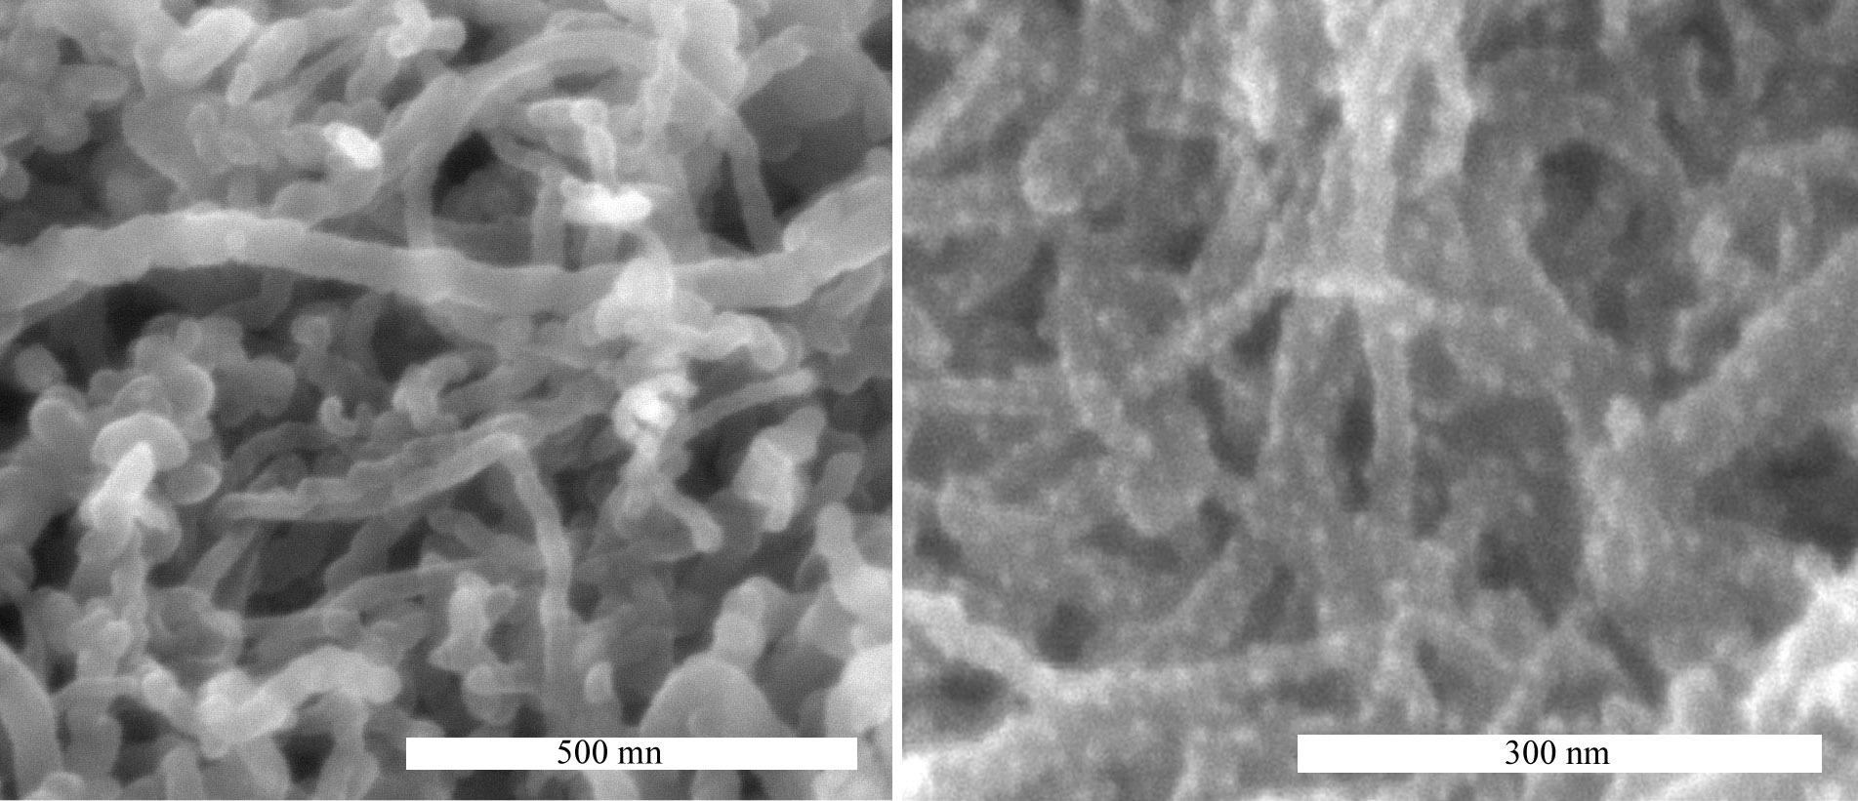

Fig. 3 SEM analysis of MWCNT/Ag hybrid filer.

Fig. 4 Final strain sensitive epoxy/glass fibres laminate with integrated MWCNT/Ag layer.

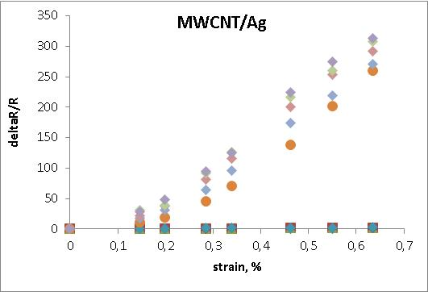

Ag particles increase strongly the resistance sensibility after pre-straining

Conclusions

Multi-walled carbon show excellent electrical properties, while polymers provide flexibility, easy manufacturing, and low cost. CNT embedded in epoxy composites reinforced glass fibers which give to the novel material high resistance, are proposed as a novel multifunctional material that can be used as not only for loading detection also for in-situ monitoring purposes while signal measuring during process. It has been proven that modification of pure CNT with Ag clusters highly amplify the sensitivity to resistance change. Pre-strain has been carried out to demonstrate the sensitivity of the sensors to deformation. Also dynamic cycles where applied to verify that the durability of the sensors and the reproducibility of the results. Longer cycles should be applied in this study but it is in perspective for future work.

Acknowledgement
This work was supported by the Ministry of Education, Youth and Sports of the Czech Republic, under the project Czech-Austrian mobility (program KONTAKT II) project -7AMB16AT033 and by the OeAD, the Austrian Agency for International Mobility and Cooperation in Education Research in collaboration with the Thomas Bata University in Zlín. This work was also supported by the Ministry of Education, Youth and Sports of the Czech Republic – Program NPU I (LO1504) and with the support of Operational Program Research and Development for Innovations co-funded by the European Regional Development Fund (ERDF) and national budget of the Czech Republic, within the framework of the project CPS-strengthening research capacity (reg. number: CZ.1.05/2.1.00/19.0409).

References
[1] Rein MD, Breuer O, Wagner HD. Sensors and sensitivity: Carbon nanotube buckypaper films as strain sensing devices. Compos Sci Technol 2011;71:373-381.
[2] Kim, Y., Kim, Y., Lee, C., Kwon, S. Thin Polysilicon Gauge for Strain Measurement of Structural Elements. IEEE Sens. J. 2010, 10, 1320−1327.
[3] Yamada, T., Hayamizu, Y., Yamamoto, Y., Yomogida, Y., Izadi-Najafabadi, A., Futaba, D., Hata, K. A stretchable carbon nanotube strain sensor for human-motion detection. Nat. Nanotechnol 6, 2011, 296–301.
[4] Slobodian P., Riha P., Saha P. A highly-deformable composite composed of an entangled network of electrically-conductive carbon-nanotubes embedded in elastic polyurethane. Carbon 2012;50:3446-3453.
[5] Slobodian P., Riha, P., Olejnik, R., Cvelbar U., Saha, P. Enhancing effect of KMnO4 oxidation of carbon nanotubes network embedded in elastic polyurethane on overall electro-mechanical properties of composite. Compos. Sci. Technol. 2013;81:54–60.
[6] Hin, M., Oh, J., Lima, M., Kozlov, M., Kim, S., Baughman, R. Elastomeric conductive composites based on carbon nanotube forests. Adv. Mater. 2010, 22, 2663–2667.
[7] Dai H, Thostenson Erik T, Schumacher T. Processing and Characterization of a Novel Distributed Strain Sensor Using Carbon Nanotube-Based Nonwoven Composites. Sensors 2015, 15, 17728-17747; doi:10.3390/s150717728
[8] Alamusi, Ning Hu, Fukunaga H, Atobe S, Liu Y, Li J. Piezoresistive Strain Sensors Made from Carbon Nanotubes Based Polymer Nanocomposites. Sensors 2011, 11, 10691-10723; doi:10.3390/s111110691

