Statistical Study of Stuck Pipe in Different Iranian Oil and Gas Fields
1-Abbas Roohi
3-Mehran Makvandi
4- Gerhard Thonhauser
1, 4-Department of Mineral Resources and Petroleum Engineering, Chair of Drilling Engineering, Montan University of Leoben, Austria
5- Department of Mineral Resources and Petroleum Engineering, Chair of Petroleum and Geothermal Energy Recovery, Montan University of Leoben, Austria

2-Khalil Shahbazi
5- Abbas Zamani
2-Petroleum University of Technology, Ahwaz, Iran
3-National Iranian Drilling Company (NIDC)

Abstract— Stuck pipe incidents are one of the most important technical challenges in the oil and gas industry which result in a significant increase in non-productive time during drilling operations and associated costs. This problem typically may occur based on the following major mechanisms: differential sticking forces, inadequate hole cleaning and the consequent formation of cuttings beds in high angle wells, chemically active formations and inadequate mud weight leading to wellbore instability, fractured/faulted formations, and over-pressured formations. Different methods have been proposed and used in the field for stuck pipe prevention and freeing of stuck pipe.
This paper presents the statistical study of about more than one thousand stuck pipe events which occurred from the early year 2004 to the end of 2006 in different fields and formations in Iran. For this purpose, drilling data including drilling mud properties, wellbore geometry, stuck pipe depth, description of stuck freeing operations and associated time, etc. were collected and categorized. The influence of various parameters on stuck pipe were studied and statistically evaluated. Based on the results of this analysis reasons for stuck pipe events and potential ways to mitigate stuck pipe are suggested.

Keywords— Stuck Pipe, Hole Size

Introduction
Over the years different problems related to oil and gas industry are identified and various solutions associated with them have been proposed. Drilling operations have been one of the most troublesome parts of oil and gas industry. During drilling a well various problems such as wellbore instability, lost circulation, kicks and blowouts and stuck pipe may be encountered [1]. Stuck pipe has been well recognized as the drilling business started [2]. This problem may occur at any stage of drilling. Stuck pipe is classified under two categories; differential pressure pipe sticking and mechanical pipe sticking. Various operational procedures are applied to free them. These procedures include working the drill string up or down, attempting to rotate the string and pumping mud or lubricator through the drill bit to aid pipe release [3]. It should be noticed that these procedures are time-consuming and costly. For each type of pipe sticking, there are signs by which it is identified. For instance, differential sticking is accompanied by ability to rotate and circulate while with mechanical only circulation is possible [2].
In Iran, a large number of pipe sticking is occurred in different fields and formations annually. Each of them has their own difficulties to free and their specific time to work on which imparts a huge financial burden. In this study, after some introductory material regarding the mechanisms of stuck pipe, the drilling data and reports of about thousand stuck cases in different fields in Iran for three years from early 2004 to 2006 were gathered and categorized. The second step was dedicated to investigation of the number of stuck pipe in each formation and field and the time elapsed to free them. The effects of different parameters (inclination angle, hole wellbore size, wellbore depth, and distance to the last casing shoe) on the number of stuck pipe occurred were investigated statistically. Finally, taking into account the investigation carried out, the probability of facing stuck pipe in different fields and formations can be induced and the importance of studying the effect of various parameters on stuck pipe occurrence is investigated.

Stuck pipe mechanism
Often during drilling operations the drill string becomes stuck. Sticking can occur while drilling, making a connection, logging, testing, or during any kind of operation which may involves leaving the equipment in the hole [4]. Generally, stuck pipe problems are divided into two categories: mechanical sticking and differential sticking. Mechanical sticking usually occurs when the drill string is moving and is caused by a physical obstruction or restriction [6]. Mechanical sticking can be classified into two major subgroups: a) Hole pack-off and bridges; stuck pipes which are related to wellbore instability or settled cuttings are in this category and b) Wellbore geometry interferences; this refers to stuck pipes which are related to the condition of wellbore geometry such as key seats or an under-gage hole.
Major causes of mechanical stuck pipe are wellbore instability and improper hole cleaning. Most wellbore instability problems are related to shale layers due to swelling and hole enlargements resulting from compressive failure owing to excessively low wellbore pressure [7]. Adequate hole cleaning, on the other hand, is an essential part of the drilling operation. If the cuttings are not removed from the well properly, they settle around the drill string causing the drill collars to become stuck. This problem is encountered often in over gauge sections where annular velocities are low. Also, risk of hole cleaning increases in directional wells. The directional well having an inclination angle between 30-60° is the worst condition for hole cleaning [5].
As the next category of stuck pipe, differential sticking is due to differential pressure forces from an overbalanced mud column acting on the drill string against a filter cake deposited on a permeable formation. The area of the pipe that is embedded into the mud-cake has a pressure equal to the formation pressure acting on it, while the pressure which acts on the other section of pipe is hydrostatic pressure in the drilling mud. When the hydrostatic pressure (P_{h}) in the well bore is higher than the formation pressure (P_{f}), there will be a net force pushing the collar towards the borehole wall. The resultant force of the overbalance acting on an area of drill string is the force that sticks the string. This type of sticking does not occur in shales and other very low permeability formations where mud filter cakes normally do not form. Commonly, differential sticking occurs when the drill string or tool is stationary (or sometimes when it is moving very slowly) [7]. If the pipe becomes stuck, every effort should be made to free it quickly. The probability of freeing stuck pipe successfully diminishes rapidly with time. Early identification of the most likely cause of a sticking problem is crucial, since each cause must be remedied with different measures. An improper reaction to a sticking problem could easily make it worse. An evaluation of the events leading up to the stuck pipe occurrence frequently indicates the most probable cause and can lead to the proper corrective measures [5].

Materials

Data assembly and quality control
The data used for this study were collected and classified from about thousand stuck pipe events occurred in various fields and formations in Iran from early 2004 to the end of 2006. A summery list of these data is showed in Table 1. All drilling data on the number of wells in each field and the time consumed to drill each of them were gathered and classified as well. After correcting and controlling the quality of collected data, 61 mentioned formations on Daily Drilling Reports (DDR) were reduced to 20 formations on the basis of lithology and pressure to have a better analysis.

Investigation of the number of stuck pipe events in various formations
Each formation has its individual properties and may affect the drilling operation in a different way from other formations.
Figure 1 indicates the number of stuck pipes occurred in different formations from 2004 to 2006. The majority of stuck pipe happened in GS1-6, Asmari, and Bangestan formations respectively. GS1-6 formation presents a rising trend in the studied time interval which might be due to increasing the number of directional wells drilled in this formation at this period of time.
Table 1 Drilling data
Rig name | Field name
Date | Well Name
Rotary system (Kelly or top drive) | Casing size & setting depth
Time consuming to work on stuck pipe | Stuck position (Hole size, Depth)
Survey data | Formation specification
Consequence of stuck pipe | Drill string situation before stuck pipe
Drilling fluid properties (density, viscosity, PV, YP, Initial and secondary gel | Drilling operation since 3 stages before stuck

Investigation of the number of stuck pipes occurred in different fields
Fields with different geological and geographical specifications require various drilling scenarios to be applied. Hence, stuck pipe depending on the field might need a specific way of freeing.

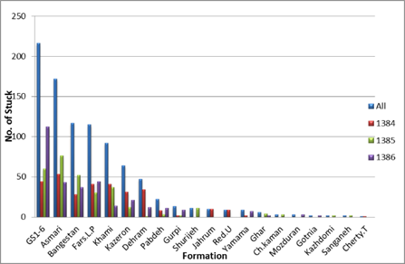
Figure 1 Number of stuck pipe events in various formations

Figure 2 presents the number of pipe sticking in different fields from 2004 to 2006. This figure shows that Marun, GS, and Ahwaz fields have the highest numbers of stuck pipes respectively.

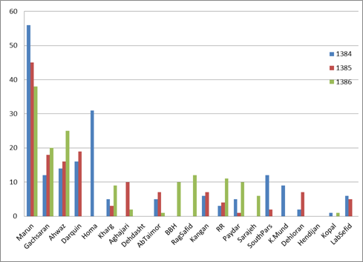
Figure 2 Number of stuck pipe events in different fields

The numbers of stuck pipe events have falling trend in Marun field in the studied time interval while GS and Ahwaz fields have rising trends at the same time interval. This contrast is highly due to the number of wells drilled every year. Hence, the number of stuck pipes in each year was divided by the number of wells drilled every year. Figure 3 exhibits the average number of pipe sticking occurred in each well. It is concluded from Figure 3 that the average numbers of stuck pipe occurred in Marun oil field for each well were reduced to 3.3, 2.6, and 2 respectively. But, GS oil field showed between 2 to 3 pipes sticking for each well without having a falling or rising trend. Ahwaz oil field presents rising trend of 1 to 1.4.

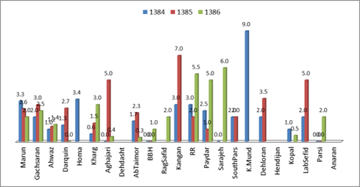
Figure 3 Normalize number of stuck per well

Khark oil field shows a rising trend, and it was 3 stucks per well in 2006. The average number of stucks in Ramshir field is high in the mentioned time interval.
In other fields due to drilling only for a short period of time and having small number of wells, does not follow a specific trend.
Since Marun oil field had majority of stuck pipe during interested time period, number of stuck in different formations of this field were taken into consideration (Figure 4). GS1-6 formations show the highest number of stucks. It shows a significant increase in 2006. Asmari formation exhibits a falling trend in the studied time interval.

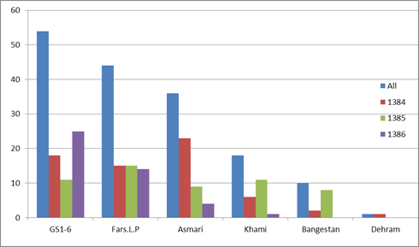
Figure 4 Number of stuck in Marun oil field

Investigation of elapsed time to free stuck pipe
Right and immediate decisions once drill string gets stuck are significantly important. In following, this issue will be demonstrated using the prepared data base. The time elapsed to work on the pipe sticking for various time intervals are investigated. Making a comparison between the number of stuck and the time elapsed to get rid of them showed that the effort to free the stuck in the first 30 minutes after pipe sticking is as valuable and crucial as the effort applied in the next 2.5 hours and in the next 100 hours to free the stuck (Figure 5). The same results were obtained after dividing them by the number of wells drilled every year.

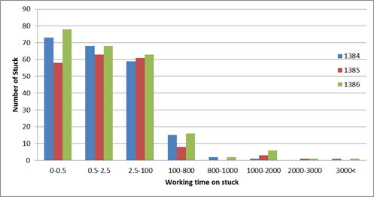
Figure 5 Comparison of the number of stuck with the time elapsed to work on them

The investigation of the number of stuck in each well based on the time elapsed to free them is presented in Figure 6. This figure demonstrates the importance of the fast and right decision in the first moments after occurring pipe sticking.
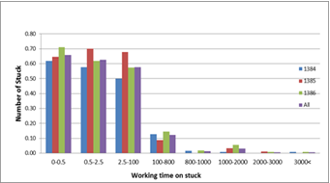
Figure 6 Number of stuck on the basis of elapsed time to free them

The elapsed time of more than 100 hours is often led to unsuccessful stuck freeing and side tracking. Same trend can be included in Marun, GS, and Ahwaz, but in other fields due to a non-continuous drilling operation, a special principle was not observed. Figure 7 shows this scenario in Marun oil field.

Impact of inclination angle on stuck pipe
Inclination angle on its own does not lead to pipe sticking but applying an inappropriate drilling method may bold the effect of inclination angle on stuck pipe.

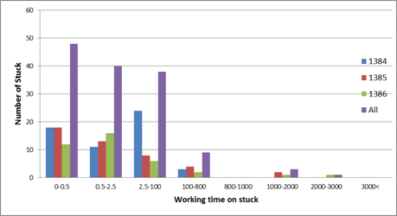
Figure 7 Average number of stuck in each well based on elapsed time to free them in Marun

Figure 8 links the number of stuck pipes with inclination angles. This figure indicates a high number of stuck in vertical wells and inclination angles of 20-40 degrees of directional wells.

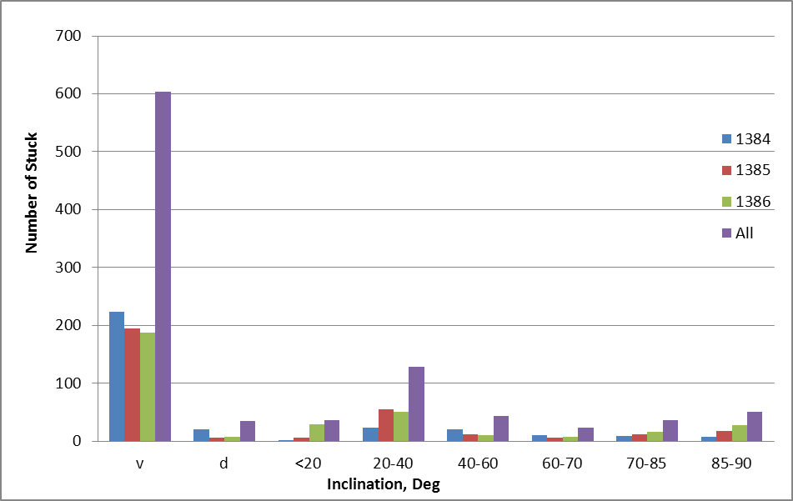
Figure 8 Number of stuck pipe events compared to the inclination angles

In the next step, the wells were classified into exploration, workover, and development wells. Figure 9 shows the number of stuck based on inclination angle and type of the well. This figure represents the variations of the number of pipe sticking in development wells with different inclination angles. Since exploration wells are drilled only in vertical, hence in exploration wells, limited data in vertical situation are available. Majority of stuck pipe in workover wells happened in vertical section and at inclination in range 20 to 40 deg.
To make our investigation more precise, the effect of formation was added to two mentioned parameters. The effect of inclination angle on stuck pipes in GS1-6 formation of development wells is indicated in figure 10. This figure shows a higher number of pipe sticking in inclination angles of 20-40 degrees of GS1-6 formation compared to other inclination angles. In other formations, a specific relationship cannot be extracted.
In the study of the effect of the time elapsed to work on the stuck pipes, in addition to the mentioned parameters, with regards to the number of directional wells drilled in GS1-6 formation, unsuccessful freeing operations in this formation in the range of 20-40 degrees of inclination angles are considerable.

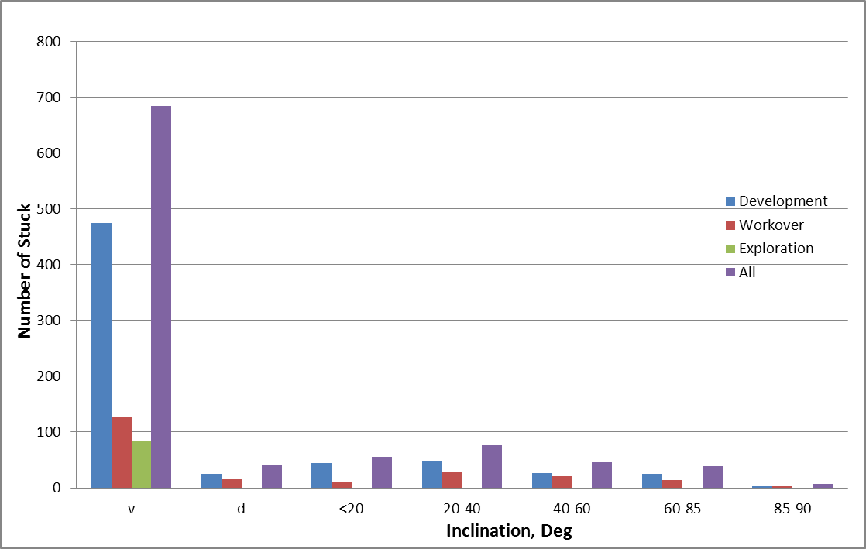
Figure 9 Number of stuck pipe occurrences based upon the inclination angles and the well type

Impact of hole size on number of stuck pipe
Stuck pipe may happen in wells at various hole sizes with regards to the chosen drilling scenario.

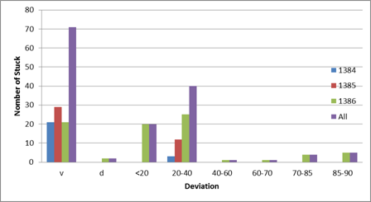
Figure 10 Effect of inclination angle on the time elapsed to work on stuck in development wells of GS1-6 formation

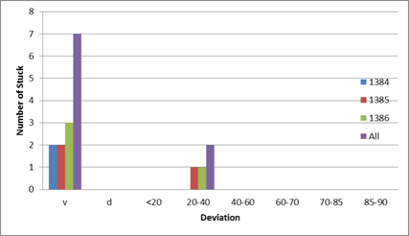
Figure 11 Impact of inclination angle on stuck pipes on development wells of GS1-6 formation

Figure 12 shows that the highest number of pipe sticking were happened in the hole sizes in range of 8 3/8 - 8 1/2, 5 7/8 - 6 1/8, 12 1/4, and 17 1/2 inches. Marun field does not follow this order.

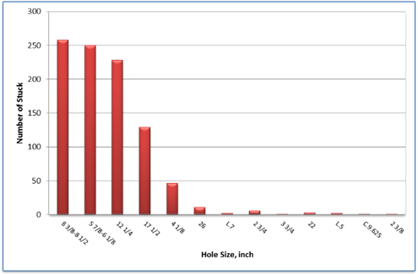
Figure 12 Number of stuck relative to the hole size

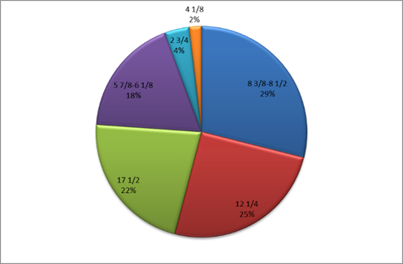
Figure 13 Number of pipe sticking in Marun field relative to the hole size

Impact of depth on number of stuck pipes
Some parameters should be noted to prevent pipe sticking. Neglecting each of these parameters can conduct to suck pipe incidents at various depths.
Figure 14 shows the number of stuck relative to the wellbore depths. As can be seen in figure 14, the higher numbers of stuck are in the range of 2500 to 3000 meters. Figure 15 indicates that the development wells of Marun field have the same condition.
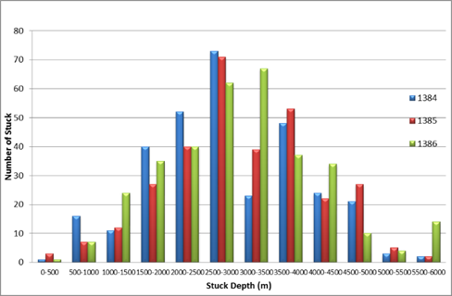
Figure 14 Number of stuck relative to the wellbore depth

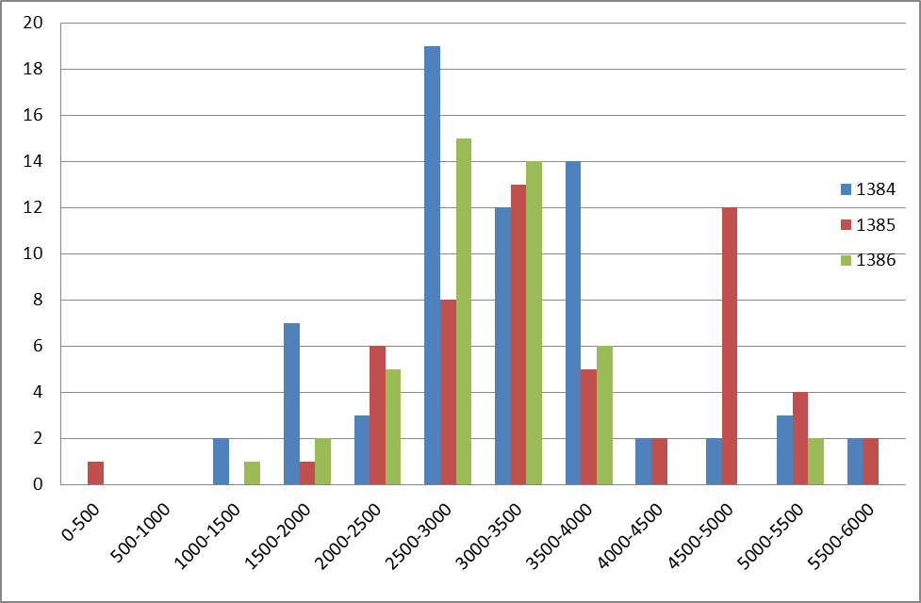
Figure 15 Number of stucks in various depths of Marun field

Impact of length of open hole on number of stuck pipes
As can be observed in figure 16, the highest numbers of stuck relative to the distance to the last casing are in the range of 200 to 400 meters. It should be noted that in longer intervals, the number of stuck reduces due to having less wells.

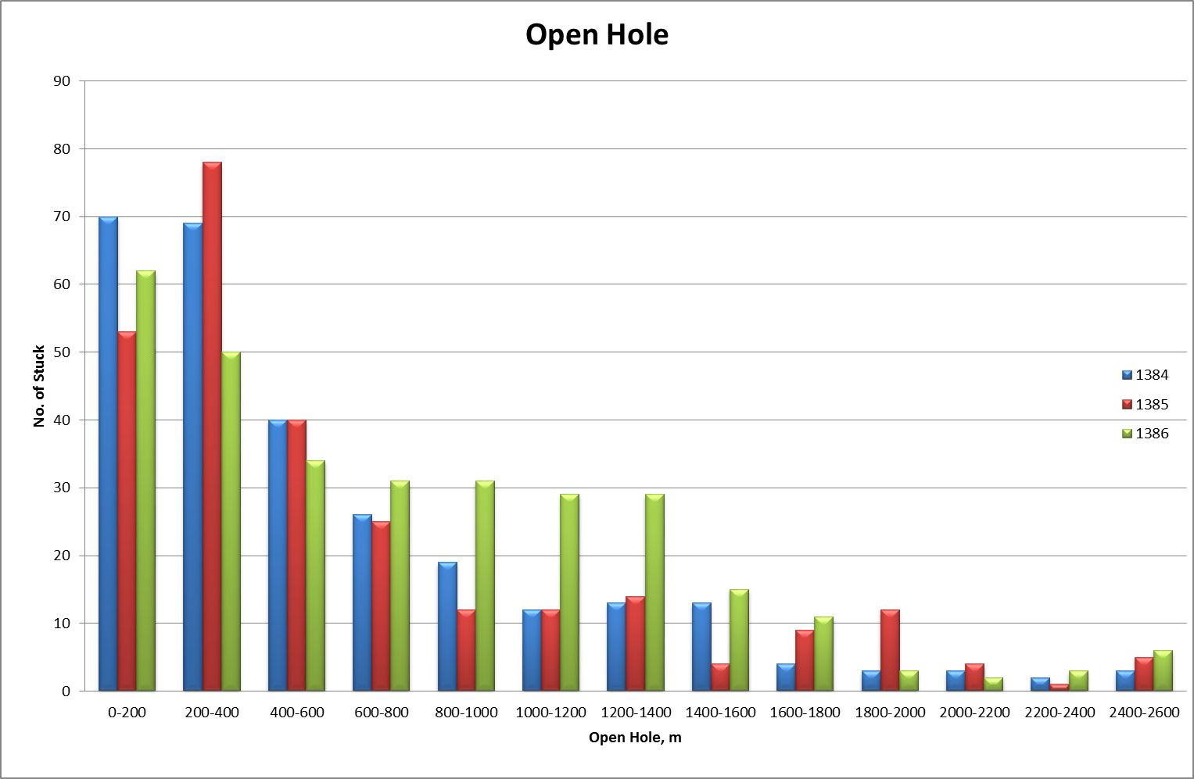
Figure 16 Number of stuck compare to the distance to the last casing

Conclusion
Primary evaluation and fast and right identification of stuck pipe play an important rule to prevent further problems which may lead to cost decrease. The first 30 minutes after happening stuck is the golden time to make a fast and right decision. The value of the efforts to free stuck in this time period is equal to the attempts applied to free the pipe sticking in the next 2.5 hours or 100 hours. On the other hand, a right decision at a right time, and following the instructions, significantly reduces the costs of freeing the stuck and as a consequence, the overall cost of drilling.
This study showed that the number of stucks happened in vertical wells is more than stucks occurred in directional wells. However, it does not mean that vertical wells are more troublesome but it is only due to drilling a higher number of vertical wells compared to the directional.
Inclination angles of between 20 to 40 degrees showed the highest numbers of stucks in directional wells.
Choosing and following a wrong way of drilling can make the hole size to be troublesome to lead to pipe sticking.
Marun field has a special condition among other fields. hole sizes of 5 7/8 – 6 1/8 inches exhibit the less stuck problems compared to other hole sizes.
Number of stuck has a direct relationship with increasing depth. Nevertheless, number of stuck in the depths of deeper than 2500-3000 meters is low which is only due to drilling fewer wells with those depths.

Acknowledgment
The work described in this paper represents the efforts of a large number of persons. The authors would like to express their thanks to National Drilling Company (NIDC) for their cooperation and supplying the required data; and thank Mr Hadi Mohammadi (Head of NIDC R&D) for his positive cooperation and help.

References
[1] Meschi, M.R., Shahbazi, K., Pordel Shahri, M., "A New Criteriato Predict Stuck Occurence", SPE 128376, SPE North Africa Conference and Exhibition, Cairo, Egypt, 14-17 Feb, 2010.
[2] Al-Dossary, A., "New Offshore Sidetrack Practices Reduced Significntly Stuck Pipes in KSA", SPE 16461, SPE IPTC, Beijing, China, 26-28 March, 2013.
[3] Aadnoy, B.S., Larsen, K., Berg, P.C., "Analysis of Stuck Pipe in Deviated Boreholes", Journal of Petroleum Science and Engineering 37 (2003) 195– 212.
[4] Bradley, W.B., Jarman, D., Plott, R.S., Wood, R.D., Schofield, T.R., Auflick, R.A., and Cocking, D., "Task force approach to reducing stuck pipe costs". Paper SPE 21999, SPE/IADC Drilling Conference, Amsterdam, Netherlands, 11-14 March (1991).
[5] Drilling Fluid Engineering Manual, MI L.L.C., Page: 15.1-15.10. March (1998).
[6] Reid, P.I., Meeten, G.H., Way, P.W., Clark, P., Chambers, B.D., Gilmour, A., and Sanders, M.W., "Differential-sticking mechanisms and a simple wellsite test for monitoring and optimizing drilling mud properties", Journal of SPE Drilling & Completion, Volume 15, Number 2, pp. 97-104 (June 2000).
[7] Zhang, J. "The impact of shale properties on wellbore stability", Dissertation, the University of Texas at Austin, (August 2005).

